*Assume gravitational field strength at/near Earth’s surface, g, is 9.8 N/kg wherever needed.*

**1** A car with a mass of 1500 kg is travelling at 30 m/s. Just as the car starts to climb a hill, the driver switches the engine off. He lets the car coast to a stop and then puts the hand brake on. The centre of mass of the car rises by *h* m.



**a)** What is the kinetic energy of the car just before the engine is turned off? (2)

**b)** If the car stops on the hill as shown in the second diagram, calculate *h*. (2)

**c)** What three forces act on the car to slow it down? (3)

**2** The diagram shows the distance–time graph of a cyclist.

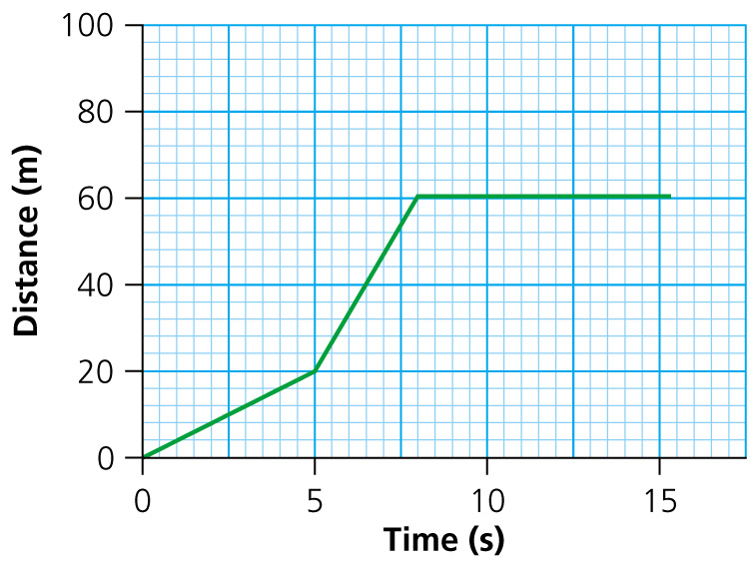

Using the distance–time graph calculate:

**a)** the speed of the cyclist over the first 5 seconds (2)

**b)** the speed of the cyclist travels between 5 and 8 seconds (2)

**c)** the speed of the cyclist for the interval 9 to 12 seconds (2)

**d)** the average speed of the cyclist in the first 8 seconds (2)

**e)** the average speed of the cyclist over 15 seconds. (2)

**3** From rest, a cheetah reaches a speed of 27 m/s in 9 seconds. What is its acceleration? (2)

**4** A formula one car travelling at 50 m/s brakes hard for a corner and decreases its speed to 10 m/s in 2 seconds.

**a)** What is its deceleration over the 2 seconds? (2)

**b)** Calculate the distance that the car travels over the 2 seconds. (2)

**5** When using the formula for Newton’s second law, *F* = *ma*, what units must be used for *a*? (1)

**6** A spacecraft on Mars has a weight of 76 000 N and a mass of 20 000 kg.

**a)** Calculate the gravitational field strength on Mars. (2)

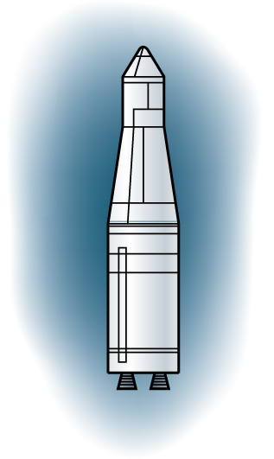

**b)** The spacecraft fires its engine and takes off from the surface of Mars. The engine delivers a force of 314 000 N.

**i)** Calculate the resultant force on the spacecraft. (2)

**ii)** Calculate the initial acceleration of the spacecraft. (2)

**c)** The spacecraft returns to Earth having shed 5000 kg of mass. What is its weight on the  Earth’s surface? (2)

**7** A man leans against a wall. He applies a force of 100 N to the wall. If the wall doesn’t fall over:

**a)** what is the force that the wall exerts on the man? (1)

**b)** is this an example of Newton’s second or third law? (1)

**8** The velocity–time graph shows the movement of a car.

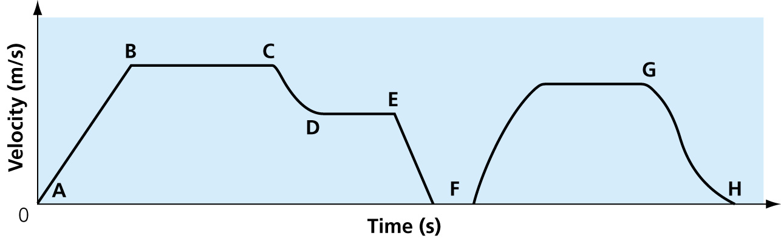

The car travels from home, at point A, to a station car park at point H. The car makes a stop at a set of traffic lights.

**a)** What is the car doing between points A and B? (1)

**b)** Between which points is the car decelerating to stop at the traffic lights? (1)

**c)** What is the car doing between points D and E. (1)

**d)** Highlight the area on the graph which could be used to calculate the distance travelled from the traffic lights to the station car park. (1)

**9** **a)** Is velocity a vector or a scalar quantity? (1)

**b)** Is momentum a vector or a scalar quantity? (1)

**c)** A car has a velocity of 30 m/s and a mass of 2000 kg. Calculate its momentum? (2)

**d)** Write the equation for Newtons second law and state the units of each component in the equation. (2)

**10** Complete the following. In a closed system, momentum is always ………………………. . (1)

**11** A professional cyclist with a mass of 80 kg accelerates from 4 m/s to 13 m/s in 3 seconds.  What force is required to do this? (2)

TOTAL = 47

**1** **a)** KE =  mv2;  × 1500 × 302 = 675 000 J (2)

**b)** KE = *mgh*; *h* =  = 45.9 m (2)

**c)** Friction, air resistance, gravity (3)

**2 a)** Speed = =  = 4 m/s (2)

**b)** Speed = =  = 13.33 m/s (2)

**c)** Speed = = 0 m/s (2)

**d)** Average speed = =  = 7.5 m/s (2)

**e)** Average speed = = = 4 m/s (2)

**3** Acceleration =  =  = 3 m/s2 (2)

**4** **a)** Deceleration = =  = 20 m/s2 (2)

**b)** *v*2 – *u*2 = 2*as*; *s* =  = 60 m (2)

**5** m/s2 (1)

**6** **a)** Weight = *m* × g (Mars); *g* (Mars) =  = 3.8 N/kg (2)

**b) i)** Resultant force = 314 000 – 76 000 = 238 000 N (2)

**ii)** *F* = *m* × *a*; *a* = = 11.9 m/s2 (2)

**c)** Mass on earth = 20 000 – 5 000 = 15 000 kg

Weight = 15 000 × 9.8 = 147 000 N (2)

**7** **a)** 100 N (1)

**b)** Third law (1)

**8** **a)** Accelerating (1)

**b)** EF (1)

**c)** Travelling at constant velocity. (1)

**d)** Highlight area under FGH. (1)

**9** **a)** Vector (1)

**b)** Vector (1)

**c)** Momentum = *mv* = 2 000 × 30 = 60 000 kg m/s (1)

**d)** *F* = *ma*; force = mass × acceleration;

Units: force, N; mass, kg; acceleration, m/s2 (2)

**10** Conserved (1)

**11** Acceleration = =  = 3 m/s2

Force = *m* × *a* = 80 × 3 = 240 N (2)

TOTAL = 47